Report and testing

Getting the ball to move around in different directions. Just ran the code to ensure that to ball is moving on the screen. This console shows that the ball is moving on the screen. This piece of code was taken out alter. This was just put in place to ensure it was working.

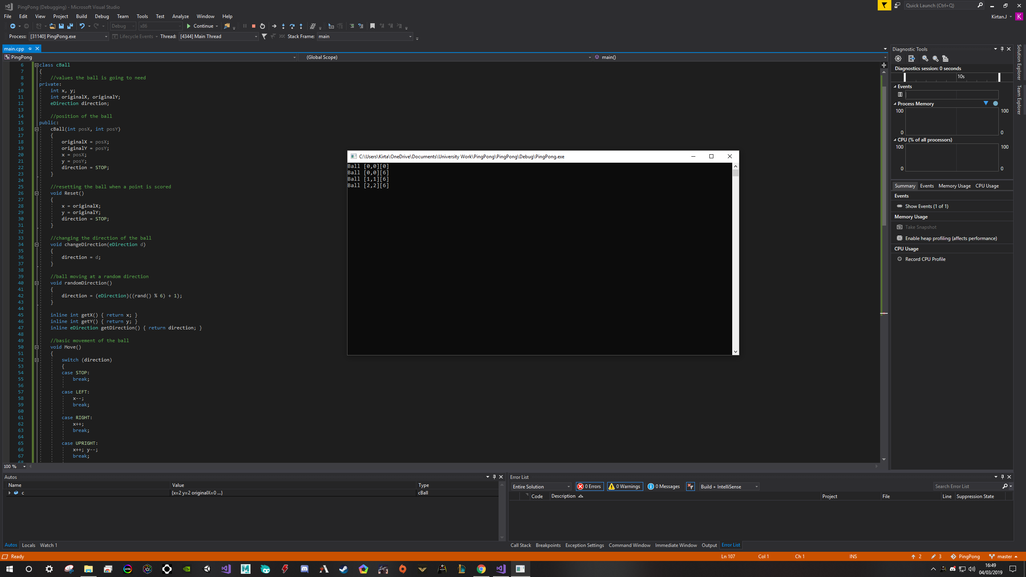

Background sprite was not loading properly at first. Put file in the wrong location. Also had the same small issue with the Arial font where it was placed in the wrong file location. Once I had the sprite loaded properly. I had to the part where the spirte is in the middle of the screen. The centre line of the render window is a sprite used. I did not use a SFML code to make a line in the middle.

Getting the text postion in the correct location. This was one of the many trail and erorr processes where I had to figure where the text needs to be positioned on thr screen. It was not too hard since I just had to centre the text abit and the move it to the side. Either left or right. Once one was set. The other one is just as simple as adding a + or – depending on which is left open.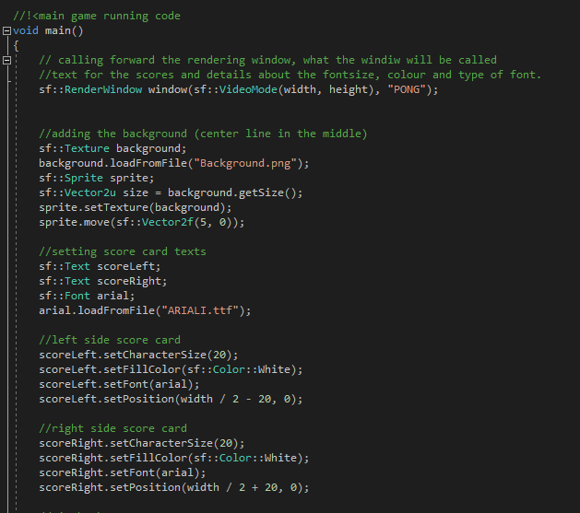

Moving to ball to the centre of the window when a side scores a point. For example if left side scores, the ball will move to the centre and start by going to the opposite of the scorer. This is to make sure that the game is not stale and the same each time. If this is not in place the ball won’t reset and it will always start in the same direction.

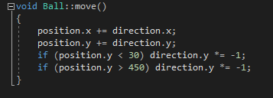

This was probably one of the hardest part of the code where I had to figure out the collisions that well be occurring in the game. I had to set collisions for the paddles to ensure the ball will come back when it is hit by a paddle. Also with this I had to implement the score counter too. Each time the ball hits the edge of the render window where there is no paddle, the ball has to reset to go to the middle (which I added in the piece of code above) and increment the score counter to whichever side scored. Had 1 issue where I just got my rights and lefts wrong.

